TEAM – 3

26230030148 – VADLAPATLA JASWIN

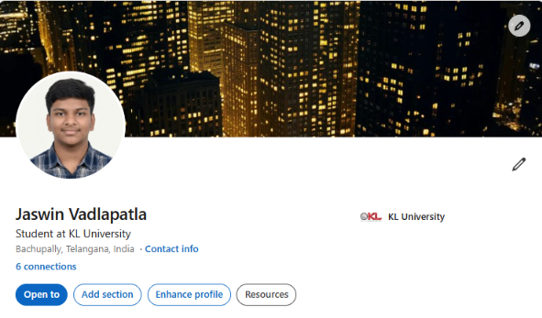

2620030170 – SAHASRA.N

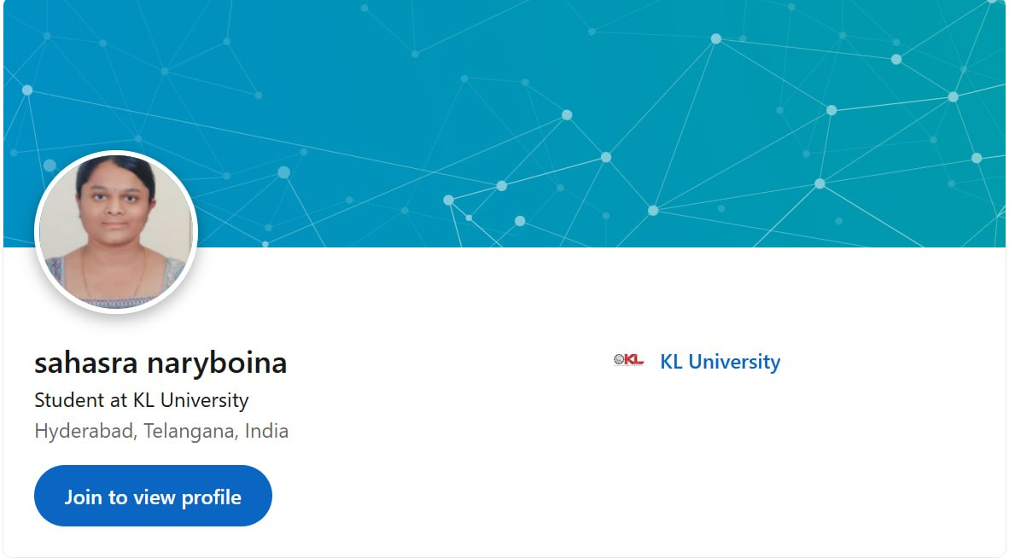

2620030108 – SAHASRA.T

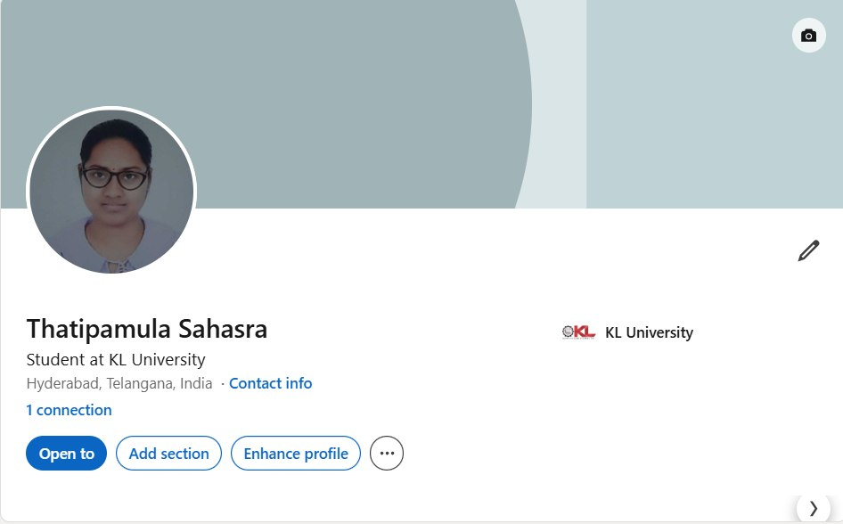
2620030173 – BHAVISHYA.V

